After you listen to the short biography (story) on the life of Sergei Prokofiev, please answer the following questions:
Where was Sergei Prokofiev born?
- France
- Ukraine
- England
- Russia
- United States
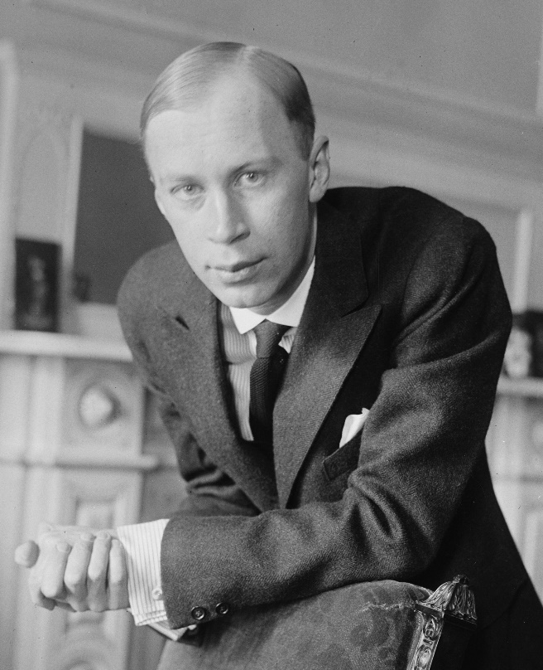
What instrument did Sergei Prokofiev play?
  - Violin
  - Tuba
  - Piano
  - Cello
  - Timpani

Who was Sergei Prokofiev’s first music teacher?
  - His mom
  - His dad
  - His sister
  - His brother
  - He went to a special music school

What was Sergei Prokofiev’s favorite game?
  - Checkers
  - Crossword Puzzles
  - Monopoly
  - Chess
  - Tennis

The biography of Sergei Prokofiev and questions 1, 2 and 4 were found on the website www.classicsforkids.com

What year was Sergei Prokofiev born?
  - 1887
  - 1890
  - 1891
  - 1802
  - 1997

How old was Sergei Prokofiev when he wrote his first piece of piano music? _______________

Why did Sergei Prokofiev go to Moscow at the age of 9?

______________________________________________________________________________

______________________________________________________________________________

______________________________________________________________________________

If you could become a famous composer, what type of music would you write? Please explain your answer in at least 3 sentences.

